REPUBLIC OF CAMEROON
**********************
Peace-Work-Fatherland
******************
MINISTER OF HIGHER EDUCATION
REPUBLIC DU CAMEROON
***********************
Paix-Travail-Patrie
********************
MINISTRE DE L’ENSEIGNEMENT SUPERIER






Bachelor of Technology Year 1 Internship Report

IMPACT OF A GOOD ANALYSIS ON DECISION MAKING

Written by: TANETCHOP LONTSI Achinelle

Professional supervisor: M. ALONTI Guy Carlos

Academic year: 2025/2026

DEDICATION

To TANECHOP ‘s Family

ACKNOWLEDGEMENT

I am deeply grateful for the invaluable assistance provide by numerous individuals in the completion of this work. while it is not feasible to acknowledgement each person individual within this text, I extend my sincerest thank to all those involved. In particular, I would like to express my proud gratitude to the following individuals:
- MR GUIMEZAP Paul: Founder and President of IUC, for his visionary leadership in establishing a conducive environment for student training and development.
- MR Gustave Casimir SAHA, CEO of NAFEX S.A for accepting me in his structure and encouraging me to work more harder.
- MR ALONTI Guy: the director of NAFEX S.A and professional for he presence, guidance, advice and dedication to work;
- Dr. KENOU Willy Chance: the Director of SEAS, for his exceptional management skills, attentive approach, and unwavering support throughout the process.
I would also like to express my gratitude to my esteemed lecturers,
both within and beyond the confines of the school premises, for their unwavering support, guidance, and imparting their knowledge, which significantly deepened my understanding of the subject matter. Furthermore, I extend my heartfelt appreciation to all my friends who contributed to the development of this work, offering their assistance and insights along the way. Lastly, I am indebted to my beloved family, especially my parents, for their unwavering moral advice and consistent financial support throughout my educational journey. Their love and encouragement have been a constant source of strength, both physically and spiritually, in my life.

ABSTRACT
In today’s world, data has become a key resource for organizations across all sectors, including financial institutions such as bureaux d’échange. Every transaction generates valuable information that, when properly analyzed, can provide insights into customer behavior, market trends, and business performance. Traditionally, many decisions in exchange offices have been based on experience or intuition. However, with the growth of digital tools and data analysis techniques, managers can now rely on factual evidence to make better decisions.This report presents the project we carried out during my internship at a bureau d’échange, focused on studying the impact of data analysis on decision-making. The project explores how transaction data—containing details such as currency type, credit, debit, exchange rate, and operation date—can be processed, analyzed, and visualized to support more effective management. By applying my knowledge as a first-year Computer Science Engineering student, we were able to use tools such as Excel and Python to transform raw data into clear insights. The goal of this work is to demonstrate how data-driven approaches can improve decision-making in currency exchange operations, making them more accurate, efficient, and profitable.

RESUME
De nos jours, les données sont devenues une ressource essentielle pour les organisations de tous les secteurs, y compris les institutions financières comme les bureaux de change. Chaque transaction génère des informations précieuses qui, lorsqu’elles sont correctement analysées, peuvent fournir des indications sur le comportement des clients, les tendances du marché et la performance de l’entreprise. Traditionnellement, de nombreuses décisions dans les bureaux de change ont été prises sur la base de l’expérience ou de l’intuition. Cependant, avec le développement des outils numériques et des techniques d’analyse de données, les gestionnaires peuvent désormais s’appuyer sur des preuves concrètes pour prendre de meilleures décisions. Ce rapport présente le projet que nous avons réalisé lors de mon stage dans un exchange office, centré sur l’étude de l’impact de l’analyse de données sur la prise de décision. Le projet explore comment les données des transactions comprenant des informations telles que le type de devise, le crédit, le débit, le taux de change et la date de l’opération peuvent être traitées, analysées et visualisées afin de soutenir une gestion plus efficace. En appliquant mes connaissances en tant qu’étudiant en première année de génie informatique, Nous avons pu utiliser des outils comme Excel et Python pour transformer des données brutes en informations claires. L’objectif de ce travail est de démontrer comment une approche fondée sur les données peut améliorer la prise de décision dans les opérations de change, en les rendant plus précises, efficaces et rentables.

TABLE CONTENT

DEDICATION 2
ACKNOWLEDGEMENT ii
ABSTRACT iii
RESUME iv
TABLE CONTENT v
CHAPTER I : GENERAL INTRODUCTION 1
I. INTRODUCTION 1
II. PROBLEM STATEMENT 1
III. OBJECTIVES 1
IV. Methodology 2
CHAPTER II: THEORETICAL FRAMEWORK 5
I. Presentation of Key Concepts 5
II. Standards or Regulations Related to the Project 5
CHAPTER III: PROJECT PRESENATION 7
I. DESCRIPTION OF THE COMPANY 7
II. IDENTIFICATION OF NEEDS OR PROBLEM 10
III. ANALYSIS OF THE CURRENT SITUATION 11
CHAPTER IV : APPROACH AND METHODOLOGY 12
I. PROJECT STEPS 12
CHAPTER V: RESULT / ARCHIEVEMENTS 15
I. RESULT OBTAIN (TABLES, GRAPHS) 15
II. INFLUENCE ON CHOICES 17
Conclusion 19
Recommendation 19

CHAPTER I : GENERAL INTRODUCTION

INTRODUCTION
Computer Science Engineering is a discipline that combines programming, algorithms, and computational methods to address practical challenges. One of its most significant applications is data analysis, which allows raw data to be organized, processed, and interpreted in order to support decision-making. In today’s data-driven world, organizations that effectively use their data are more efficient, competitive, and able to adapt to market changes. In the financial sector, and particularly in today’s global economy, financial institutions and exchange offices handle large volumes of data every day. The accuracy and quality of this data play a crucial role in ensuring transparency, efficiency, and profitability. A exchange office (currency exchange office) relies on data such as transaction records, exchange rates, and customer operations to make informed decisions. Good data analysis can help detect patterns, reduce errors, and improve decision-making processes.

PROBLEM STATEMENT
In a exchange office, many financial transactions are carried out daily, involving credits, debits, and exchange rates. Although these transactions are recorded, the data is often underused, and most decisions are taken based on experience or intuition. This can create inefficiencies, such as poor anticipation of customer demand, difficulties in managing liquidity, and missed opportunities to increase profitability.In particular, the Dirham (DHS) represents a significant part of the bureau’s daily operations. However, the flows of DHS transactions are not systematically analyzed to detect trends or to evaluate performance. Without proper analysis, managers may overlook important insights that could improve decision-making and strengthen financial management.This project seeks to address this problem by analyzing transaction data from April, May, and June 2025, focusing specifically on DHS operations. The aim is to show how data analysis can transform raw transaction records into useful information that supports more accurate, efficient, and profitable decisions in a exchange office.

OBJECTIVES

- General Objective
The general objective of this project is to study the impact of data analysis on decision-making in a exchange office, by analyzing three months of transaction data (April to June 2025) related to the Dirham (DHS). The aim is to demonstrate how raw transaction data can be transformed into useful insights that support efficiency, optimize liquidity management, and increase profitability.
- Specific Objectives
To achieve this general goal, the project focuses on the following specific objectives:
Collect and prepare DHS transaction data from April to June 2025 for analysis.
- Counting the number of transaction executed per day.
- Analyze DHS demand trends over the three-month period.
- Examine variations in exchange rates and their impact on transaction volumes.
- Visualize the results using graphs and dashboards for easier interpretation.
- Provide insights to support decision-making in areas such as exchange rate adjustments, liquidity planning, and operational efficiency.
This way, our report clearly states:
Period analyzed → April–June 2025
Currency analyzed → DHS only.

Methodology
The methodology describes the approach used to analyze DHS transactions and demonstrate the impact of data analysis on decision-making in the exchange office. The analysis was performed at both daily and monthly levels to provide both operational and strategic insights.
- Data Collection
Daily transaction records provided by the exchange office.
Period Covered: 01 April 2025 – 01 July 2025.
Fields Collected: Date of transaction
Libellé / Description
Crédit (DHS inflow)
Débit (DHS outflow)
Taux (applied exchange rate)
Référence (transaction ID)
Initial balance: Starting amount (Solde)
- Data Cleaning and Preparation
Ensured all dates were consistent in format.
Converted Crédit and Débit values to numeric format.
Checked for missing or incorrect entries and corrected them. Calculated Net Flow for each transaction:
{Net Flow} = initial balance +{Crédit} - {Débit}
Created a cumulative balance to monitor DHS liquidity over time.
- Daily Transaction Analysis
For this analysis, all transaction record were grouped by their respective dates. The total number of transactions for each day was then calculated. This provides insight into the frequency and distribution of the account activity on a daily basis, allowing for the identification of transaction patterns and any unusual spikes or dips in daily operations.
- Monthly Transaction Analysis
Aggregated daily data into monthly summaries.
Calculated: Total Crédit and Débit per month, Net monthly flow , within the month
Analyzed trends to identify: Deficit months, Periods of high variability
Purpose: To understand long-term trends, support strategic planning, and make data-driven decisions about reserves and staffing.
- Tools Used
Microsoft Excel: it acted as both database and preprocessing environment, providing a format that the app cloud read and analyze to support chart plotting, summary calculation, and interactive exploration of financial transaction.
Python (optional): it acted as the backend engine for data processing and visualization in your app, enabling interactive analysis of your financial data.
- Summary of Approach
This methodology allowed a comprehensive analysis of DHS flows and also involved uploading of a financial transaction dataset stored in an Excel file (Analysis.xls) into the Data Visualiser App. Python was used as the backend to process this data, extracting key metrics such as total Credit, total Debit, and balance. The app provides interactive options to select variables for the x-axis and y-axis and offers different plot types for visualizing trends and patterns over time. Data was grouped by transaction date to calculate daily summaries and transaction counts. Applying formulas like net flow
Net Flow=Initial Balance + Credit - Debit
Net Flow=Initial Balance +Credit - Debit helped track the evolving account balance. The methodology emphasizes on Excel for data storage and preprocessing, with Python facilitating dynamic analysis and visualization through the app interface. This approach enables efficient, user-driven exploration and clear graphical representation of financial transactions and daily activities.

CHAPTER II: THEORETICAL FRAMEWORK

Theoretical framework of this project is based on fundamental principles of financial data analysis and visualization. It relies on accounting concepts such as debits, credits, and balance calculations to effectively interpret transaction data. Conceptually, the project applies data aggregation and visualization techniques to transform raw transaction records into meaningful insights. Visualization methods such as line charts and bar charts are used to represent trends, fluctuations, and patterns in financial activity over time.
Additionally, the project leverages software engineering principles by using Excel as a data storage and preprocessing tool, while Python serves as the analytical engine. This hybrid approach enables precise calculation of net flows and balances, improves data interaction, and facilitates decision-making through visual summarization. This framework guides the methodology by informing the selection of tools, calculations, and visual representation throughout the project.

Presentation of Key Concepts
The essential terms and concepts used in our project are included as follow:
- Transaction volume: The total number of financial transactions within a period.
- Liquidity management: Strategies to ensure sufficient cash flow to meet exchange demands.
- Exchange rate variations: Fluctuations in currency values affecting transaction volumes and profitability.

Standards or Regulations Related to the Project
This project operates within the framework of applicable financial standards and regulatory requirements governing bureaus de change and financial data management. Key standards include compliance with anti-money laundering (AML) laws and customer due diligence (CDD) policies to ensure transparency and prevent illicit activities. Data privacy regulations mandate secure handling and confidentiality of transaction records, protecting customer information from unauthorized access. Additionally, the project aligns with industry best practices for financial reporting and liquidity management to promote accuracy, accountability, and operational efficiency. Adhering to these standards ensures the project’s outcomes are reliable, compliant, and support the bureau’s legal and ethical obligations.

CHAPTER III: PROJECT PRESENATION

DESCRIPTION OF THE COMPANY
This section will enable us first to describe NAFEX in terms of its history, missions, objectives and legal form, and then to describe the organization and operation of the said structure.
- Internal Presentation
These are factors that are specific to a company and show its status.
- History, missions, objectives and legal form
- Company history
Every structure set up has a history and a mission that justifies its existence. The exchange office NAFEX SA located in the city DOUALA more precisely in AKWA chapel Bonadibong is a company of physical person is operational under decree n° 0000284 of March 10, 2025 carrying approval of Mr. ALONTI SAH Guy Carlos in quality of manager. Its promoter is Mr. SAHA Gustave Casimir, with a capital of 60,000,000 FCFA, and its main activity is the “PURCHASE AND SALE OF CURRENCY” and its secondary activity is the “VIREMENT FOURNISSEUR”
- Missions
A exchange office is a financial service institution that specializes in the exchange of foreign currencies. Its main mission is to provide customers with the ability to buy and sell different currencies at competitive exchange rates. In addition, the bureau ensures compliance with financial regulations and provides a secure and reliable service for both individual and business clients.
- Objectives
An objective is the result to be achieved in carrying out an operation by a given date. AS a service provider, NAFEX SA's main objective is to satisfy its customers and their needs.
- Legal form
A company is a legal fiction conferring legal personality on an economic entity made up of several people who pool goods, rights, capital or services for a purpose determined by their agreements. This is the case of the NAFEX SA exchange office, which has a sole shareholder as president, with a capital of 60,000,000 FCFA. These characteristics give it the legal status of a limited company.
- Identification of the company
Elements Characteristics
ELEMENTS | CHARACTERISTICS
Registered name | Exchange office
Sigle | NAFEX SA
Legal form | Société anonyme
NIU | M072318488479J
Date of creation | 10 March 2025
Capital | 60 000 000 FCFA
RCCM registration number | RC/DLA/2023/B/4356
Main activity | Purchase of foreign Currency
Secondary activity | Supplier transfer
Tax system | Simplified
Number of employees | 03
Owner | SAHA GUSTAVE CASIMIR
phone | 675 931 676/ 655 600 868
Location | AKWA (chapelle bonadibong)
E-mail | Nafex2023@yahoo.fr
Address | 128 DOUALA-AKWA
- NAFEX SA exchange office activities
Like all exchange offices, NAFEX SA is privately owned and specializes in buying and selling foreign currency. To this end, it provides its customers with foreign currencies such as EURO, DOLLAR and YEN. We also offer international money transfers.
- Structural organization
A company's structure defines the hierarchical and functional relationships between its various employees. It involves the division of responsibilities and the company's internal communication system.

- organization and Operation
The bureau is organized around daily operations of currency exchange, which include receiving money from clients, converting it into the requested currency, and providing the equivalent amount based on the applicable exchange rate. The staff is responsible for handling transactions, managing liquidity (availability of cash in different currencies), and reporting financial activities. Decision-making often involves determining appropriate exchange rates, ensuring the availability of popular currencies such as USD, DHS and EUR, and monitoring profitability.
- Exchange office structure
The structure is defined as the sum of the means employed to divide work into distinct tasks.
Tasks are divided and responsibilities shared. NAFEX SA is structured as follows:
-general management
-accounting department
- cashier
- NAFEX SA exchange office operations
To make the company's operations more complete, each manager is assigned a specific task, to enable him or her to better assimilate his or her duties. These tasks are divided up as follows:
- Management
This is carried out by a General Manager, Mr. ALONTI SAH CARLOS, who is considered to be the strategic body of the office. He is responsible for:
-implementing the company's general policy
- ensuring the smooth running of day-to-day operations (transaction processing system)
- The accounting and tax department
A tax accountant is responsible for:
-daily recording of foreign exchange transactions
-accounting for cash movements
-calculation and recording of margins on operations
-filing tax returns
ensuring compliance with tax obligations
- cash department
The activity of this department is more central and sensitive, as it is in direct contact with cash flows. It is run by a cashier who is responsible for:
-receiving customer funds
-carrying out customers' foreign exchange transaction
-manages the funds in the safe
-ensures cash disbursements

IDENTIFICATION OF NEEDS OR PROBLEM
The project arises from the need to effectively manage and analyze large volumes of financial transactions recorded daily. Existing manual or basic spreadsheet methods are often time-consuming, prone to errors, and lack advanced visualization capabilities necessary for insightful decision-making. There is a clear demand for an automated tool that can accurately read transaction data from Excel files, compute essential metrics such as total credits, debits, and balances, and provide interactive visual representations to reveal trends and patterns over time.
Meeting this need will enhance the understanding and monitoring of financial activities, allow quicker access to key information, and support better financial management decisions with clear and concise visual data summaries.

ANALYSIS OF THE CURRENT SITUATION
Currently, financial transaction data is managed either manually or with basic spreadsheet tools. These methods present several limitations:
Data entry and processing are time-consuming and increase the risk of human error. Tracking and summarizing credits, debits, and balances requires repetitive manual calculation. There is no automated system for visualizing trends, or for quickly identifying anomalies and patterns in transaction activities. As a result, it is difficult for staff to efficiently monitor financial movements and to make timely, informed decisions. The lack of real-time insights and user-friendly analytical tools means important financial information can be missed or misunderstood. Modernizing the process with automated data handling and interactive visualization is therefore essential to address these challenges, increase efficiency, and improve transparency of financial operations.

CHAPTER IV : APPROACH AND METHODOLOGY

PROJECT STEPS

- Data collection
For this project, the bureau provided transaction data covering the period from April 1st, 2025, to July 1st, 2025. The dataset includes the following key information:
Date of Operation: the date when the transaction was carried out.
Reference: a unique identifier for each transaction.
Libelle: description of the transaction, including the currency (e.g., USD, DHS).
Credit: amount of money received.
Debit: amount of money paid out.
Exchange Rate (Taux): the rate applied to the transaction
This data forms the basis of the analysis, allowing for calculations of daily transaction occurrence, monthly transaction(
ops: representation of number of transaction executed per month.
Net: balance(solde) per month.
Inflow (Crédit)/outflow (Débit): the amount of inflow and out flow per month.
And evaluation of trends that can support better decision-making lated daily totals of Crédit and Débit.
Created a cumulative balance to track DHS liquidity over time.
Identified high inflow and high outflow days to detect peaks and shortages.
- Monthly Transaction Analysis: Aggregated daily transactions into monthly summaries.
Calculated:
Total Crédit and Débit per month
Net monthly flow (balance or solde)
The most frequent client.
Analyzed trends to identify surplus or deficit months and highlight periods requiring better liquidity planning.
- Tools Used
- Microsoft Excel: for cleaning, calculations, pivot tables, and charts
- Python (optional): for automating calculations and generating visualizations

- Summary
This two-level approach (daily and monthly) allowed for:
- Immediate operational insights (day-to-day cash flow management)
- Strategic insights (monthly trends, peak periods, and liquidity planning)
- The focus was only on DHS transactions.

- Data Cleaning and Preparation
Removed duplicates and corrected formatting errors in dates and numbers also Converted columns such as Date of Operation, Debit, Credit, Taux into usable formats. Ensured consistency in transaction references.
- Data Analysis
Calculation: computed as Daily transaction for each operation. Trend Analysis: studied DHS inflows and outflows over time. Exchange Rate Analysis: checked how variations in the exchange rate impacted volumes.
- Data Visualization
Used graphs and charts (line plots and bar charts) to represent daily transaction, volumes ,total Crédit exchange, total Débit exchanged, and rate variations. Built a Streamlit dashboard to allow interactive exploration of the data (filtering by date, showing summaries, etc.).
- Interpretation and Insights (Decision Making)
Interpreted the results to identify demand patterns, profitability trends, and possible improvements. Linked the findings to decision-making needs such as rate adjustments, liquidity planning, and profit monitoring.
Indicators Selected
For the analysis, the following indicators were chosen: All transaction, daily transaction, monthly quantity, the most frequent client, final balance of DHS exchanged over the 3-month, average exchange Rate over time: changes in applied rates across the three months, trend Over Time: comparison of April, May, and June to detect seasonal or monthly differences.

CHAPTER V: RESULT / ARCHIEVEMENTS

RESULT OBTAIN (TABLES, GRAPHS)

We are now going to view how we executed each of the above information about our project. firstly, let view the data we have to process given that we calculate our solde in excel from the formular (net flow =initial balance +inflow – outflow). Now the data wasview as below
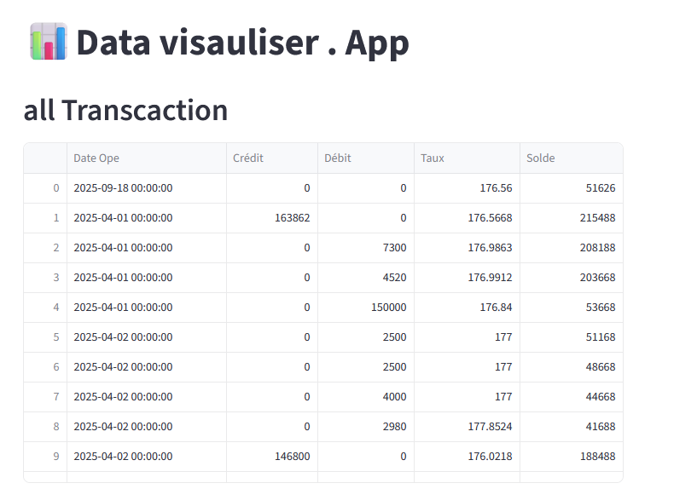

From the above information, we calculated the number of transactions executed per day (daily transaction) as shown below.
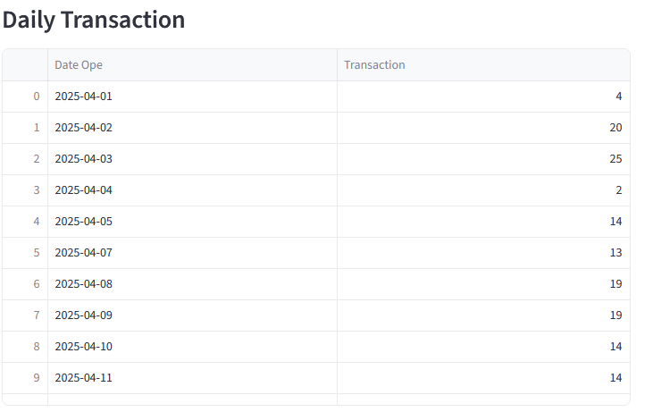

We also did a monthly analysis, which was compose of inflow per month, outflow per month, balance (net)per month, number of transaction(ops) as shown below.
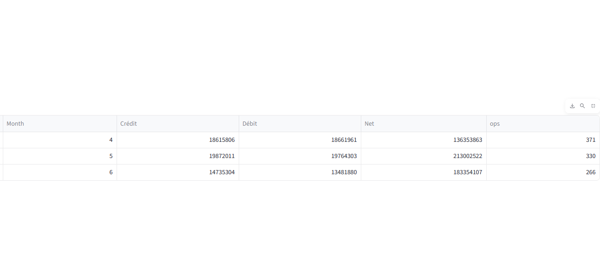

We also identified the most frequent all along this period client for strategic.
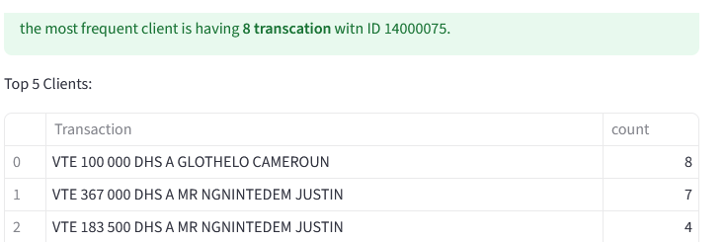
This is how transaction varies with time.
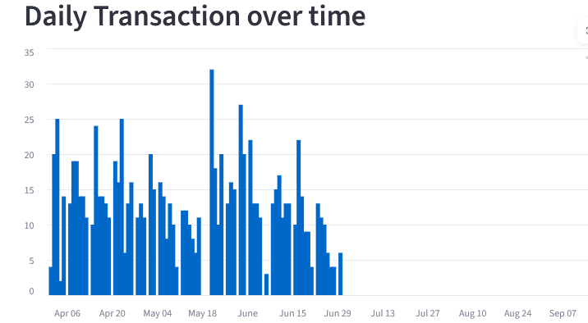

This is how balance varies with time.
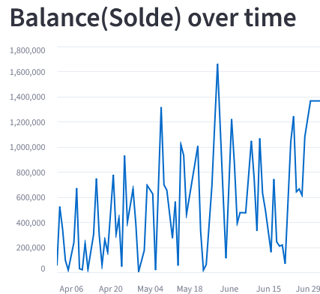

INFLUENCE ON CHOICES
The analysis of the data revealed a significant increase in daily transactions beginning in mid-May, which is also reflected in the peak balance observed during the same period. This correlation between transaction volume and account balance provides important insights into the dynamics at play within the exchange office operations. One plausible factor contributing to this trend is the increased travel activity toward Dubai, especially since Dubai is known as a country with an open market that attracts numerous visitors and business activities. This influx of people likely led to a heightened demand for currency exchange services, thereby increasing both the volume of transactions and the cash reserves held by the bureau. Understanding such patterns is crucial for effective liquidity management, enabling the bureau to anticipate periods of high demand and allocate resources accordingly. This data-driven insight supports more informed, strategic decision-making, ensuring operational efficiency and profitability during peak periods. Moreover, recognizing external socioeconomic influences allows the bureau to adapt its services proactively, meeting customer needs while minimizing financial risks.
- Problems Encountered During Execution
During the project execution, we face as challenges to calculate the profit over this 3 month since in an exchange office (exchange office), the is an initial amount of exchange rate (rate at which the buy currency) and a final amount of exchange rate (rate at which the sell currency) which is essential for-profit calculation. Infact, the data that was given to me was having only a final amount of exchange rate. This is one of the reasons we could not calculate the profit along this period of April-June.
Despite these challenges, effective problem-solving and iterative development approaches ensured the successful completion of the project deliverables.

Conclusion
his project successfully demonstrated the value of data analysis in improving decision-making within a exchange office, specifically focusing on DHS transactions over a three-month period. By examining transaction volumes, demand trends, and exchange rate variations, the project provided actionable insights that enhance operational efficiency, liquidity management, and profitability. The observed increase in transactions and peak balances in mid-May, linked to external factors such as travel trends to Dubai, underscores the importance of understanding socioeconomic influences on currency exchange activities. Overall, this data-driven approach equips the bureau with the knowledge to optimize resources and make more accurate, timely decisions.

Recommendation
- Implement an automated system to continuously collect, process, and analyze DHS transaction data, providing timely and accurate insights to support decision-making.
- Utilize advanced data visualization tools to effectively monitor daily transaction volumes and account balances, enabling early detection of trends and abnormal activities.
- The administration should ensure that sufficient cash reserves are maintained during peak periods—such as mid-May when transaction activity increases significantly—to meet the heightened demand and facilitate smooth currency exchanges.
- Adjust operational strategies based on thorough analysis of demand trends, especially during times of increased travel or other economic events that impact transaction volumes.
- Regularly monitor exchange rate fluctuations and evaluate their effects on transaction volumes to optimize pricing strategies and liquidity management.
- Provide ongoing training for staff to enhance their ability to interpret data-driven reports and apply insights effectively in daily operations.
- Expand the scope of future data analyses to cover longer time periods and include additional financial metrics to gain a deeper understanding of bureau performance and market dynamics.

